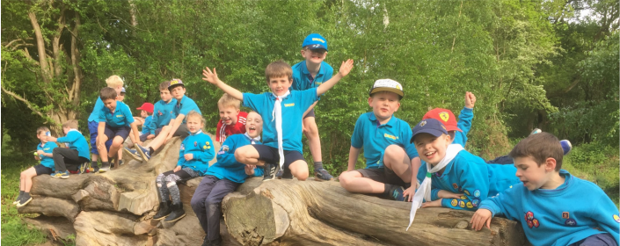




1st Fetcham Scout Group is open to boys and girls of all ages.
-

The Scout Association’s balanced programme spans the 6 - 25 age range in five
Sections. Beavers, Cubs, Scouts, Explorers and Network.


Bocketts Colony (suspended) Monday 5-6pm
Norbury Colony Wednesday 5-6pm

6 - 8 year olds Hawks Colony Thursday 5-6pm

Mole Pack Monday 6.30-8pm
Downs Pack Tuesday 6.30-8pm
8-10½ year olds Centenary Pack Wednesday 6.30-8pm

Badingham Troop Friday 7.30-9.30pm
10½ - 14 year olds Cannon Troop Friday 7.30-9.30pm


Fetcham Explorer Wednesday
@ Bookham Scouting Centre
14-18 year olds Scout Unit 7.30-9.30pm

